Affordable Care Act notice and information

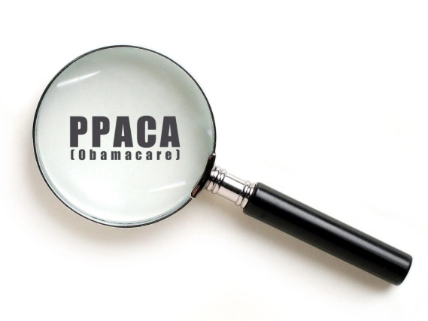
The Patient Protection and Affordable Care Act (aka - health care reform, Obamacare, PPACA, the Affordable Care Act, etc.) requires all employers to send out a notice (below) informing you about some of your health care options that open up on October 1, 2013. In addition to sending you this notice, we'd also like to provide some general information about the Affordable Care Act (ACA) and outline how it affects you.

The ACA has developed a reputation for being somewhat byzantine, and this intimidates a lot of people. Fear not - your full-service Human Resources department is on the job! Following is a brief summary of (1) what has already been implemented, (2) what will be implemented in the future, (3) what this means for you, and (4) a notice from the Department of Labor regarding the upcoming opening of the health care exchanges. If you feel you have a pretty good grasp on the ACA (or if you don't especially care about background details) feel free to skip directly to sections 3 and 4 to find out the "so what" of it all.

1) the Present: what is already in effect
Here's what the ACA has been doing for you since March 2010. These changes have already been incorporated into [the company]’s plans, so make sure you're taking full advantage:
- You
  - Free (for the insured) annual health exams, immunizations, mammograms, and screenings for certain diseases.
  - Primary-care referrals for OB/GYN visits or out-of-network emergency care are no longer required.
  - An end to lifetime limits on health insurance coverage.
  - Higher annual limits on health insurance coverage.
  - Medicare Part D prescription "doughnut hole" gap partially closed.
  - A solution for early retirees to have coverage until the retiree is old enough to qualify for Medicare.
- Your children
  - Children under 19 can no longer be denied coverage due to pre-existing conditions.
  - Free (for the insured) annual wellness exams and immunizations for children under 21.
  - Children under 26 can remain on their parents' health insurance policy.
- Your rights
  - Insurers are no longer able to cancel/rescind/deny coverage due to minor mistakes or omissions on applications. If the premium is paid, the policy must remain in force.
  - Individuals whose claims were rejected or had coverage cancelled are able to appeal via an independent, third-party review panel.

2) the Future: upcoming changes
Here are the changes that are coming in the future:
- October 1, 2013
- Health insurance exchanges - which are online marketplaces for you to browse and purchase independent medical insurance - will be available to the public, with premium subsidies for those who qualify.
- 2014
  - All Americans with pre-existing conditions will be insurable.
  - Most individuals and families will be required to carry a minimum level of health insurance, subject to a (minor) tax penalty if not compliant (for more information on the Individual Mandate, click here).
  - Most individual and group insurance plans will be required to include mental health and addiction services.
  - An end to annual limits on health insurance coverage.
  - More individuals will be eligible to enroll in Medicaid.
- 2015
  - The employer mandate - which will fine medium+ sized employers who don't provide affordable medical coverage - will go into effect.
- 2020
  - Medicare Part D prescription "doughnut hole" completely closed.

3) the So What: how does this affect me?
The above information is great, but what does this mean for you? Starting in January 2014, you will have a couple of options for choosing your
healthcare plan:
- Enroll in one of [the company]’s insurance plans. We like taking care of you, so we will continue to offer affordable health insurance to all full-time employees in 2014. This insurance coverage will satisfy the requirements under the ACA regulations so that you won't be fined under the Individual Mandate. If you enroll in one of our plans, you will qualify for [the company]’s contribution to your premium. As a reminder: open enrollment for our plans will be November of this year. If you are already enrolled in one of our medical plans and don't want to change anything, then you're already taken care of for 2014. Additional information about our plans can be found on the benefits page of the HR site.
- Enroll in coverage through a health care exchange. If you don't want to enroll in one of [the company]’s medical plans, you will be able to use a health care exchange to (1) find a plan and (2) see if you qualify for a government subsidy. If you choose this route, however, you may forfeit [the company]’s contribution to your premium. Open enrollment for these health plans is between October 1, 2013 and March 31, 2014. If you'd like to learn more about whether the health care exchange is an appropriate avenue for you, check out the government's brief health care questionnaire for guidance.
- Obtain coverage through a spouse's/partner's/parent's plan. As long as the plan which covers you meets the Individual Mandate requirements, you won't be fined; the government doesn't especially care who the primary insured is. They just care that you're covered.
- Don't enroll in any medical insurance, and absorb the corresponding fine. I strongly discourage taking this route (swing by my office sometime for some cautionary horror stories), but it is an option for you.

4) and now, a message from our Sponsor: the notice
The federal government has set up a user-friendly website to help us navigate through the various health insurance exchanges. They've also provided a notice (below) for us to share with you:

As ever, if you have any questions, feel free to talk with your friendly neighborhood human resources representative.

